MARKET ANALYSIS REPORT ON NATIONAL CLOTHING CHAIN

INTRODUCTION

The National Clothing Chain desires to create a targeted marketing campaign because sales have been flat and they want to lure lost customers back. They are interested in knowing which product to advertise to which customer in which location with three products in mind:

1. Leather bag
2. Shirts
3. Sweater

For this reason, data was collected from the US Census Bureau, Business Data, Customer Data. These data have been cleaned, modeled and analyzed to solve the problems faced by the National Clothing Chain using Power BI.

FINDINGS

* There is a very strong positive correlation between income sales with a correlation coefficient of 0.78 (Final Formula : x = -722.14 -y /-0.01).
* There is a strong negative correlation between customer ratings and product return rate with a correlation coefficient of 0.69.
* Jon Little is predicted to be the highest income earner. This was achieved using the regression formula: x = -722.14 – y / -m
* There has been a 91.35% reduction in sales this quarter (Jan – March 2021) as compared to the last quarter (Oct – Dec 2020)
* About 89% of customers are within the age range of 20 – 50 years.
* About 71% of customers are medium income earners.
* Chronograph Watch is the best rated product while Winter Gloves and Wool Scarf are the least rated products.

RECOMMENDATIONS

* Leather bag is one of the least rated products. Customers’ comments and feedbacks should be held succinctly, and efforts geared toward making the necessary improvement. For this reason, I suggest that among the three suggested products, Leather bag should be advertised the most and if possible, the price should be reduced a bit. Again, it should be marketed in the higher income states and states with high number of customers (i.e; California).
* Sweater should be marketed most in the states of Alaska, North Dakota, Maine, Minnesota, Wyoming and the other states marked as coldest states in the analysis.
* Shirts, in all have a favorable rating at a fairly good price. Of all the four different kinds of shirts, Polo Shirt is the best rated product. These products could be marketed in almost all the states.
* Chronograph Watch is highly rated and should be added to the products.
* Fair majority of the customers are in the age range of 20 – 45 years and highly incomed person belongs to 35-44, so it will be a good business decision to market products in these aged categories.

**Detailed Overview:**

1. **Data Source**

These are the provided tables I used while making reports:

1. Average Income by State
2. Customer List
3. Incomes by State
4. Industries
5. Product Inventory
6. Purchase List
7. Regression Table
8. State List
9. **Data Transformations**

**Product Inventory:**

Before:

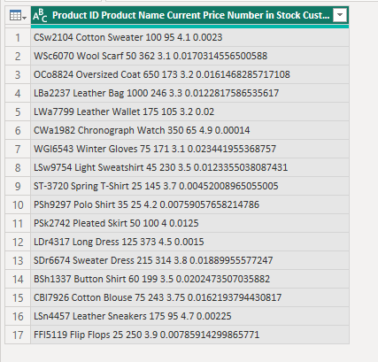

After:

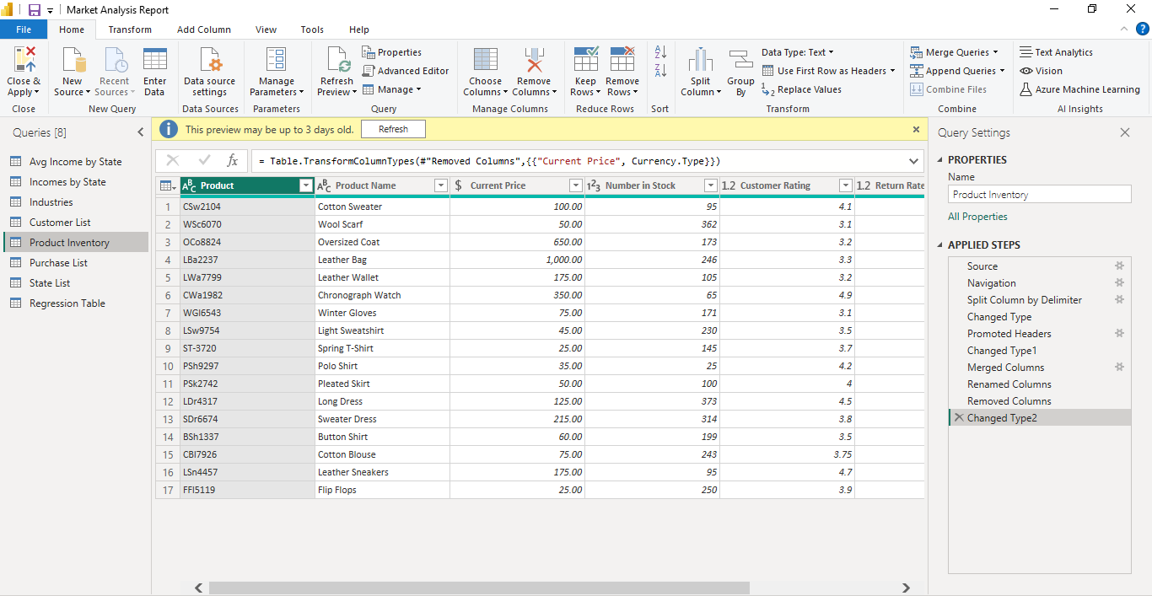

**Purchases List:**

Before:

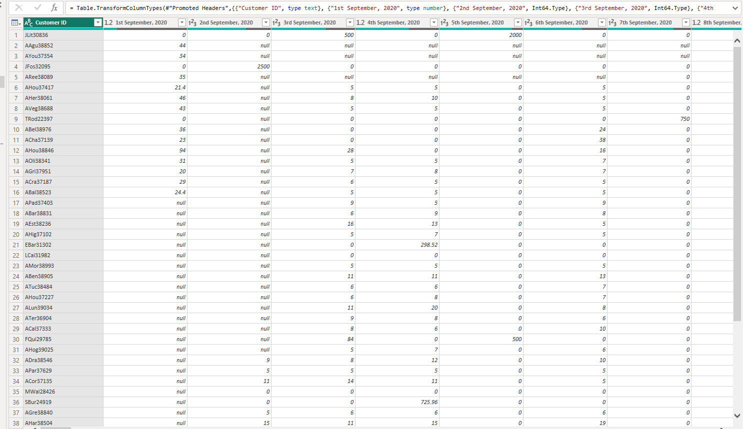

After:

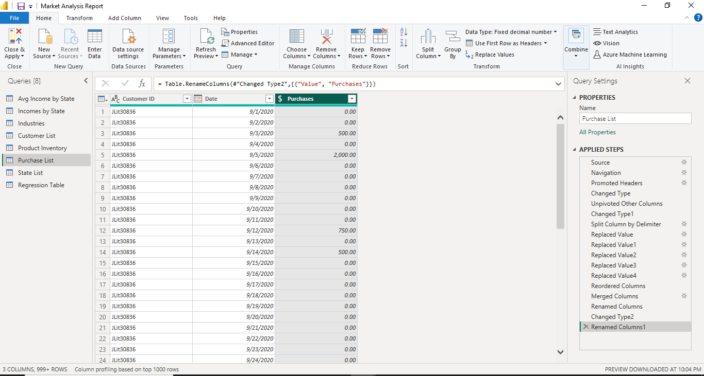

**Customer List:**

From DOB of customer, I first derived age of each customer by applying query and then labeled them as in which age bucket they belong as follow:

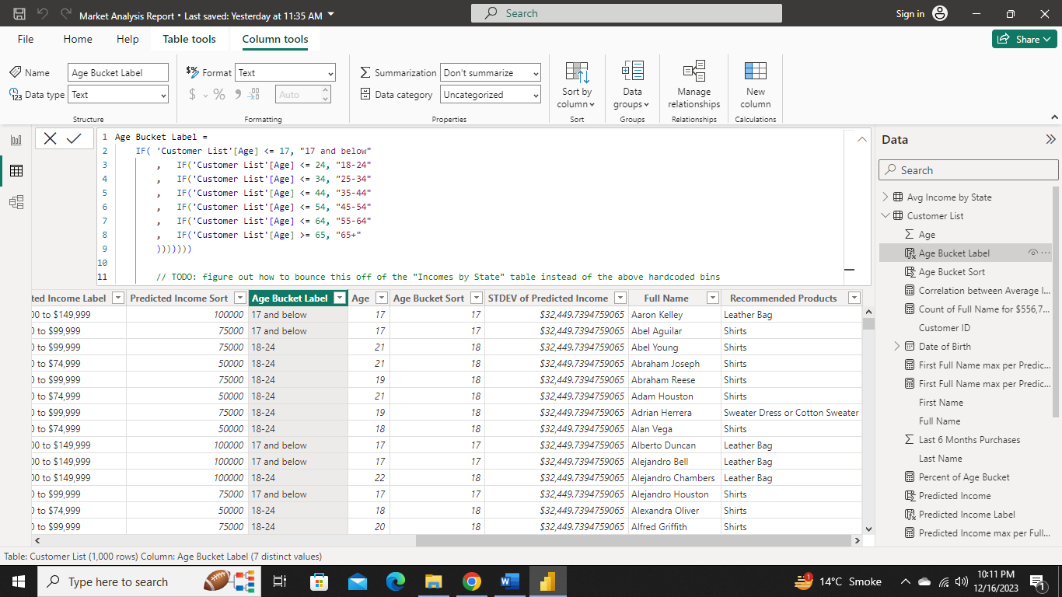

I also predicted income of each customer by the help of regression table after applying this query:

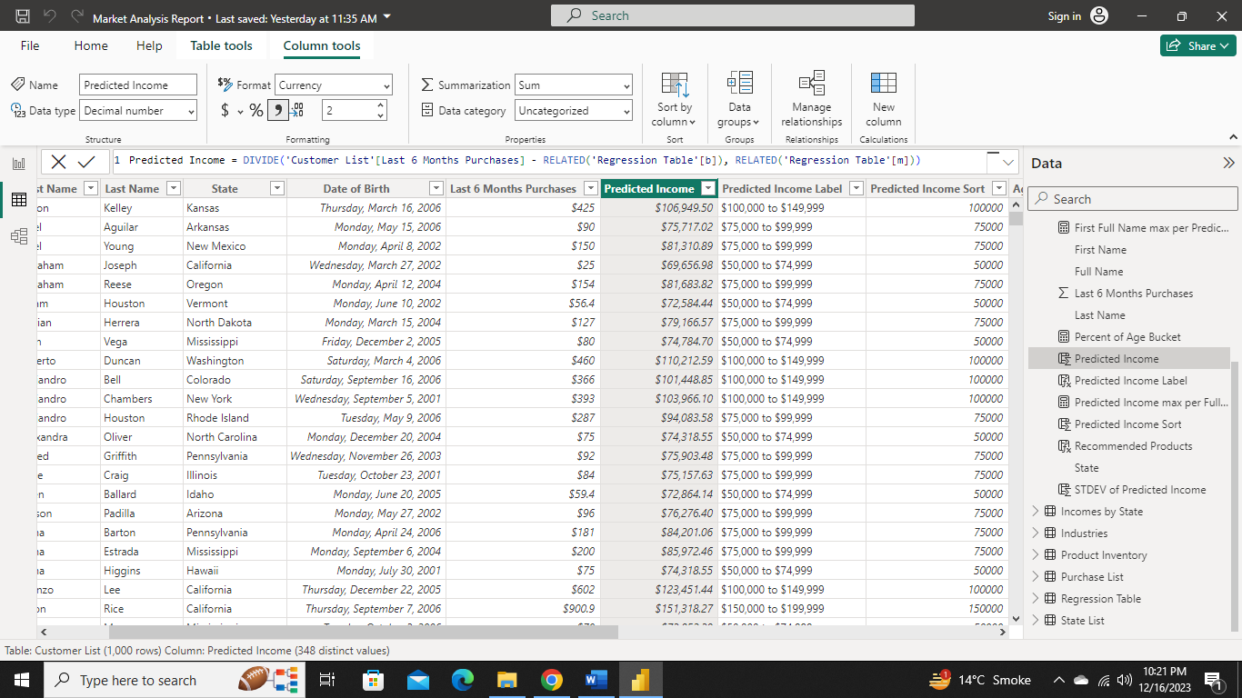

1. **Data Modeling**



1. **Analysis and Visualization**

This report consists of three pages:

1. Summary
2. Products
3. Customers

**Summary:**

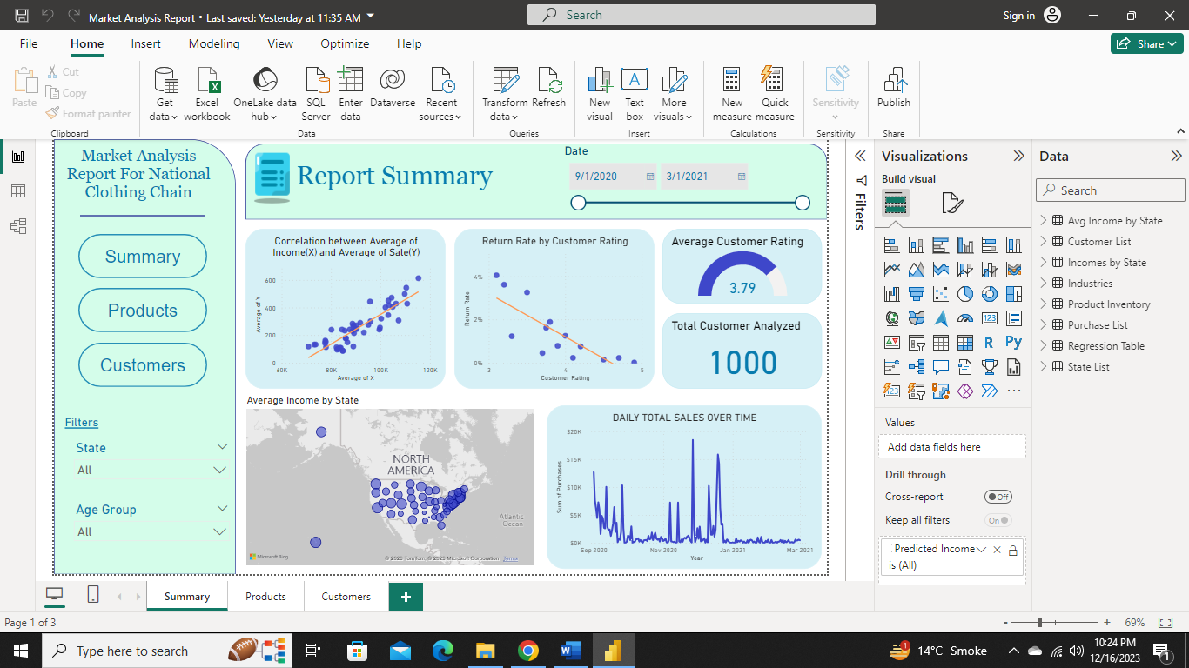

The summary page provide an overview of the solutions to the business problems listed above. It contains buttons to each page, filters and visuals for addressing a particular business problem.

**Average Income vs Average Sales**

* There is a strong positive correlation between Average Income and Sales with a correlation coefficient of **0.78**
* The regression formula: x = -722.14 – y / -m

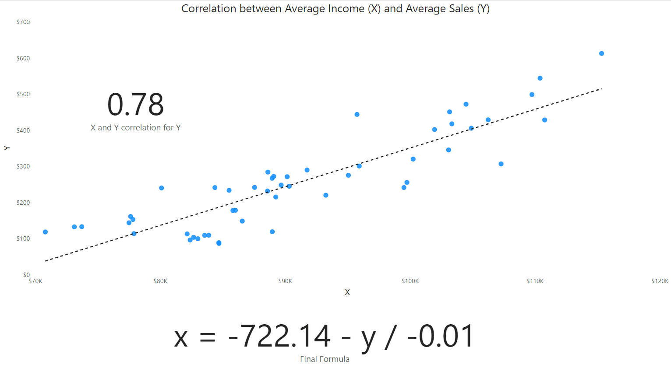

**Return Rate by Customer Ratings**

* There is a strong negative correlation between customer ratings and product return rate with a correlation coefficient of **0.69**

**Sales over Time**

* There has been a 91.35% reduction in sales this quarter (Jan – March 2021) as compared to the last quarter (Oct – Dec 2020)

**Product Analysis:**

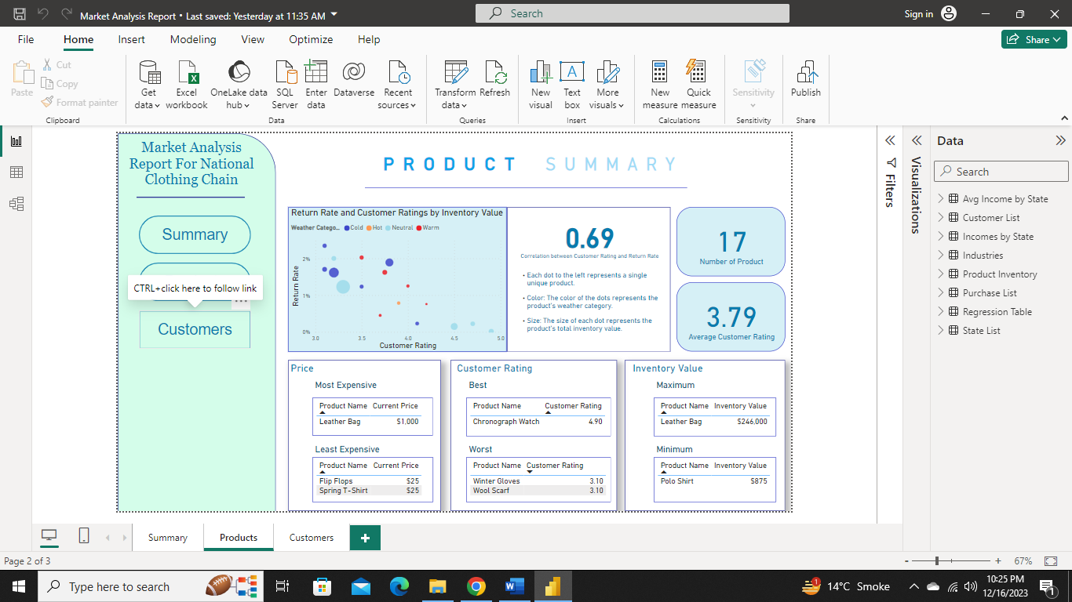

* Total number of products are 17.
* Chronograph Watch is the best rated product with a rating of **4.90**
* Winter Gloves and Wool Scarf are the least rated products with a rating of **3.10**
* Average customer rating was 3.79.
* We have $246,000 inventory value of Leather bag.

**Customer Analysis:**

* Jon Little is predicted to be the highest income earner 💰 . This was achieved using the regression formula: x = -722.14 – y / -m.
* California is the state with high numbers of customer.
* About 89% of customers are within the age range of 20 – 50 years.
* Sweater should be marketed most in the states of Alaska, North Dakota, Maine, Minnesota, Wyoming and shirts should be promoted in the state of Florida, Texas ,New York , Illinois and Pennsylvania.

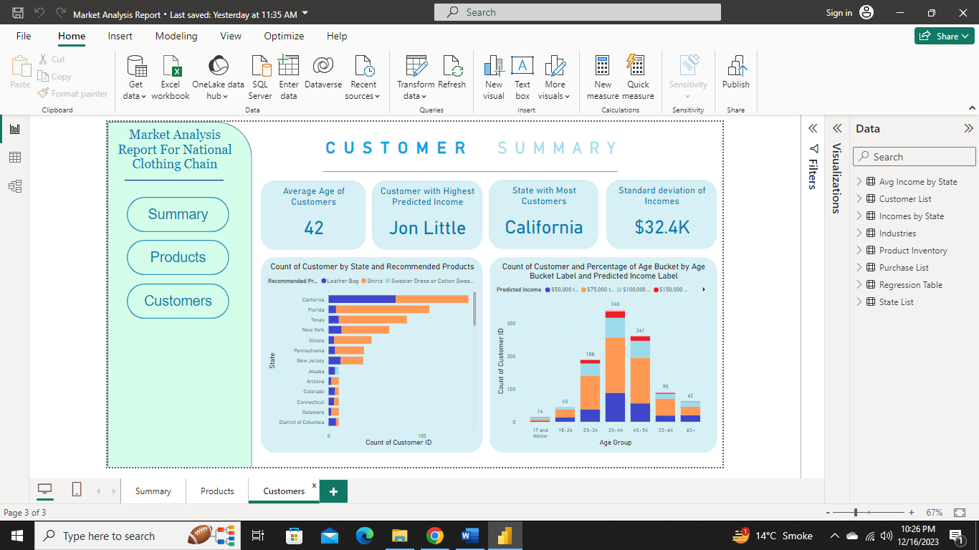

#### **Thank You 🤝**